NIP Project — Submission Template
Pega Platform project · This document is your complete submission
Read this before you start:
1. Fill in Section 1 completely. The Pega application name must follow the format NIP-[Project]-[YourName].
2. Create a new Operator in Pega with your full name and log in as that operator before taking any screenshot.
3. When you create your test case, enter YOUR FULL NAME in the Issue Description (Vehicle) or Movie Name (Movie) field.
4. Complete only the section for your chosen project. Delete the other project section.
5. Paste one screenshot per user story (10 total). Follow the screenshot rules in your selected project section.
6. Answer every question in Sections 3 and 4 in your own words.
7. Save the file using this format: ProjectName_FirstName_LastName.docx. Use VehicleService or MovieTicket as the ProjectName. Examples: VehicleService_Ravi_Kumar.docx or MovieTicket_Ravi_Kumar.docx.

Section 1 — Your Details
Full Name | Ghantasala Rama Kousalya
Email ID (registered on NIP) | 23891a0585@vignanits.ac.in
Phone Number | 8977920679
College Name | Vignan Institute of Technology and Science
Course (e.g. IT, CS) | Computer Science and Engineering (CSE)
State | Telangana
Project Chosen (Vehicle Service OR Movie Ticket Booking) | Movie Ticket Booking
Pega Application Name (e.g. NIP-VehicleService-YourName) | NIP_MovieTicketBooking_Ghantasala_RamaKousalya
Case Type Name (exact) | Movie Ticket Request
Pega Instance URL | https://jkxwcprf.pegaacademy.net/prweb/app/movie-ticket-booking-ghantasala-rama-kousalya/1O3kfChUoyqPj2zmFwqFq7C8uA6oWcaK*/!STANDARD?pzuiactionzzz=CXtycX01ODBjZTI2ZGMwZGUwMzRmYWRkMmY5N2M1MTI3OWYzMmM1NzI3OGI1YzUzNDg3OWNkY2Y1NWJiM2Q3NzFmMDYzNTBiY2U0NWViODQxZjE3MzBhZDZkNzIwM2Y5MjZlNjQ3MjkwM2FiNWMwM2I3ZmYxNzk0OTE4MDI2ZDJkY2JhZg%3D%3D*&AccessGroupName=MovieTic%3AAuthors&Location=pzuiactionzzz%3DCXtycX04NGMxYjM0MGRhY2Q2ZTgwMjJjMTczZTk5NzI4YWRiOGJhMTE3Y2YzODhhYzg2MTJjZDcxODBiOGQ5ZDIxZjMzYTJmY2Y2NGQ3MGY1OWI3OTRmODAwNDJiNmE4M2VhNzc%3D*&eventSrcSection=Embed-Stage.pzPersonas
Operator Name (created in Pega with your full name) | Operator ID – Rama Kousalya  Password – rules  Full Name – Ghantasala Rama Kousalya
Section 2B — Movie Ticket Booking Management Application
Complete this section only if you selected this project. Delete the other project section before submitting.

Screenshot rules — IMPORTANT before you start:
1. Name your Pega application as: NIP-VehicleService-YourName OR NIP-MovieTicket-YourName
2. Create a new Operator in Pega with your full name (Security → Operators) and log in as that operator.
3. When you create your test case, enter YOUR FULL NAME in the Issue Description (Vehicle) or Movie Name (Movie) field.
4. The logged-in operator name must be visible in every screenshot wherever the Pega interface displays it.
5. The student's full name must be visible in all running-case screenshots.
6. Configuration screenshots must clearly show the relevant application or rule name.
Screenshots that do not show these will not be accepted.

US-001 — Submit Movie Ticket Request
What is expected:
Case created, customer submits Movie Name, Show Date, Show Time, Number of Tickets. Validation applied.
Screenshot — paste your screenshot below this line:
[ Paste screenshot here - follow the screenshot rules above ]

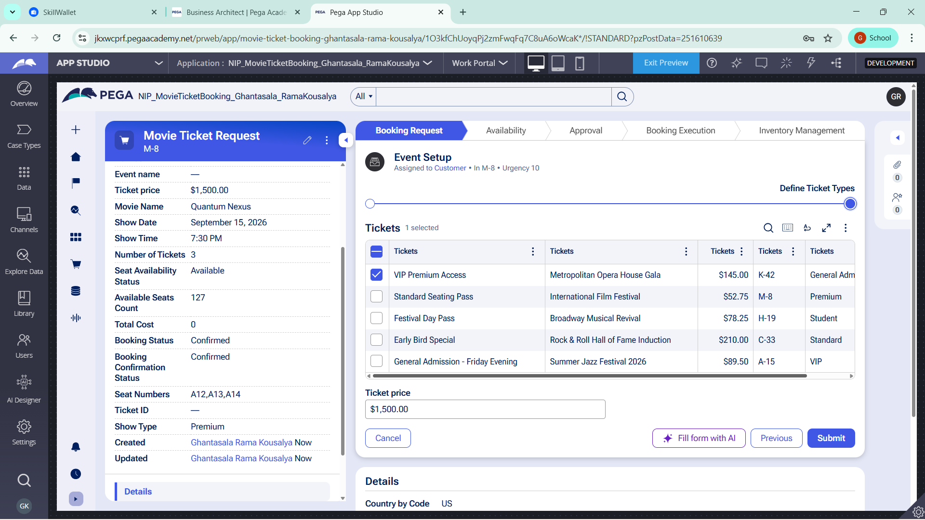

What I built for this (1–2 lines in your own words):
I created a Movie Ticket Request case where the customer enters the movie name, show date, show time and number of tickets. I also added validation to ensure the required booking details are entered before submission.

US-002 — Check Show Availability
What is expected:
Availability stage. Seat Availability Status and Available Seats Count captured. Booking proceeds only if available.
Screenshot — paste your screenshot below this line:
[ Paste screenshot here - follow the screenshot rules above ]

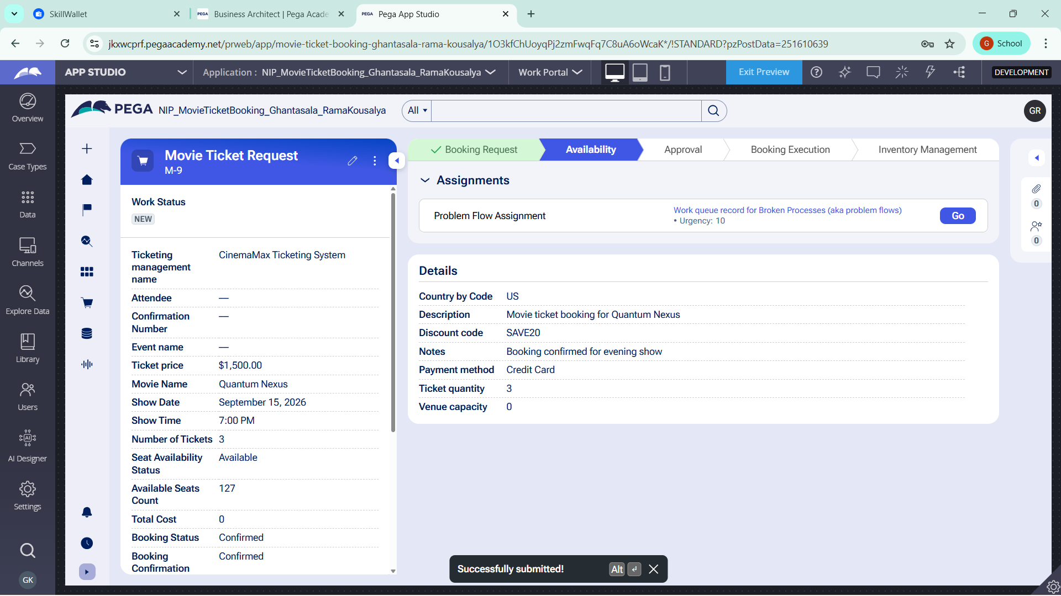

What I built for this (1–2 lines in your own words):
I added an Availability stage that captures the seat availability status and available seat count. The booking is allowed to proceed only when seats are available.

US-003 — Calculate Booking Cost
What is expected:
Total Cost calculated automatically from Ticket Price and Number of Tickets using a business rule.
Screenshot — paste your screenshot below this line:
[ Paste screenshot here - follow the screenshot rules above ]

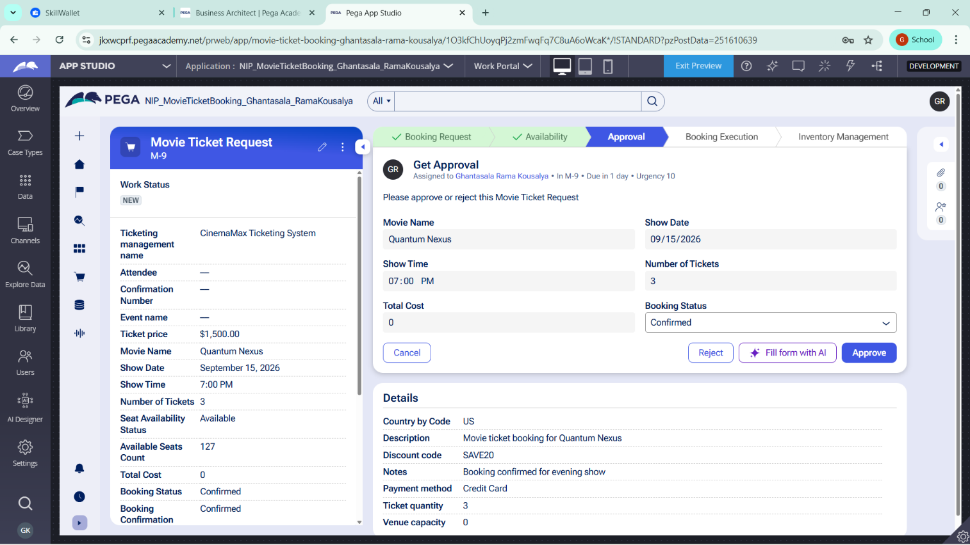

What I built for this (1–2 lines in your own words):
I configured the Total Cost calculation using the Ticket Price and Number of Tickets. The total amount is calculated automatically using a Pega business rule.

US-004 — Confirm Booking Request
What is expected:
Approval stage assigned to Customer. Booking Status captured. Flow branches on confirm/cancel.
Screenshot — paste your screenshot below this line:
[ Paste screenshot here - follow the screenshot rules above ]

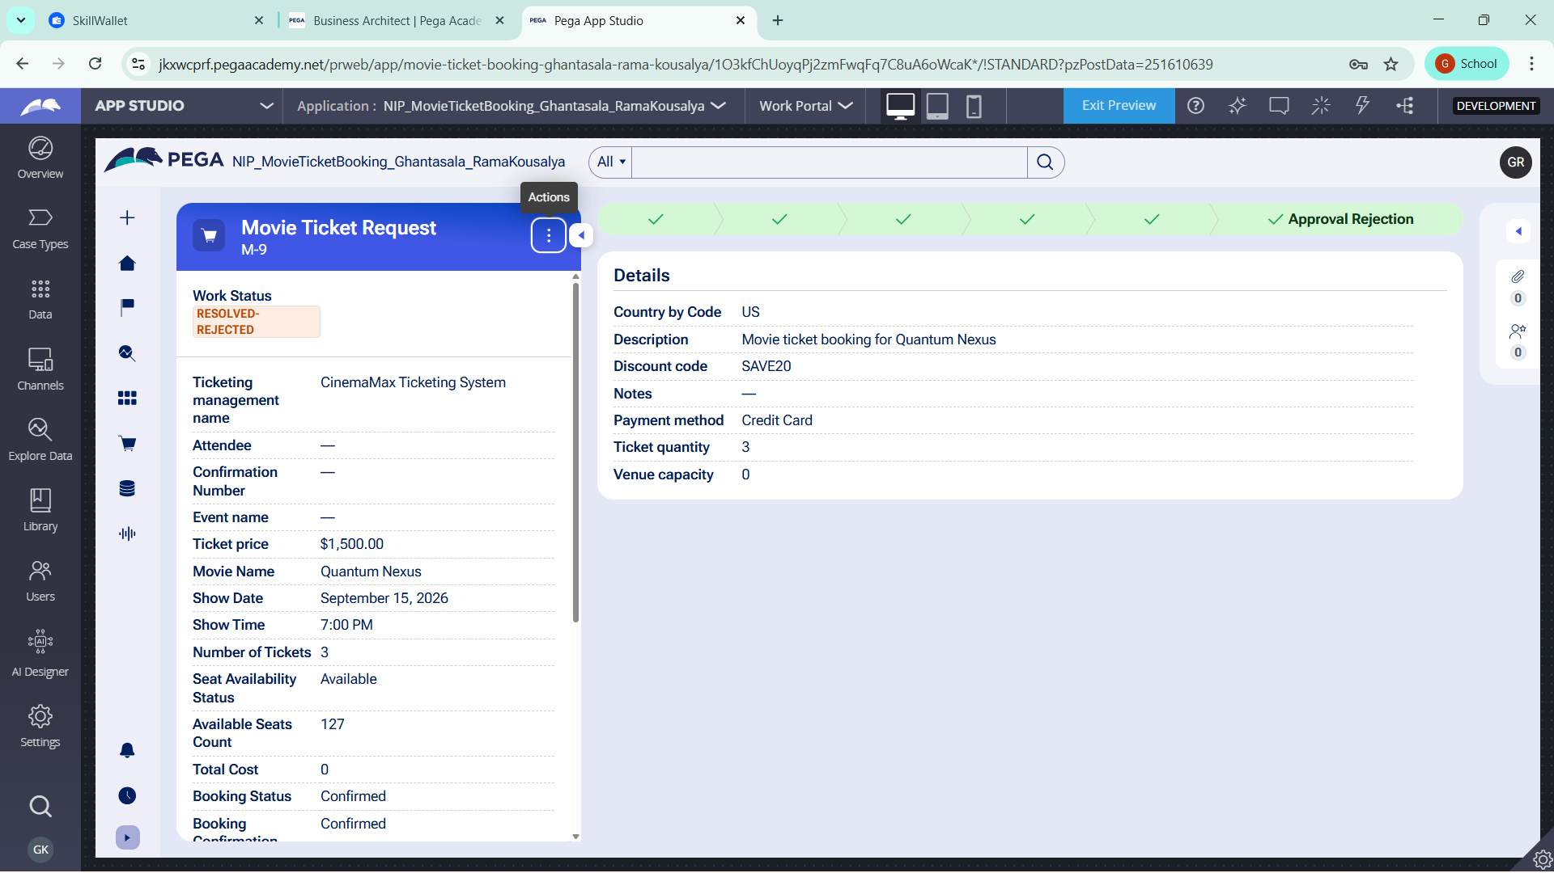

What I built for this (1–2 lines in your own words):
I created an approval step assigned to the Customer where the customer can confirm or cancel the booking. The Booking Status is updated according to the customer's decision.

US-005 — Maintain Movie and Show Data
What is expected:
Reusable Movie and Show data objects created with Movie Name, Genre, Show Date, Show Time, Seat Capacity — linked to case.
Screenshot — paste your screenshot below this line:
[ Paste screenshot here - follow the screenshot rules above ]

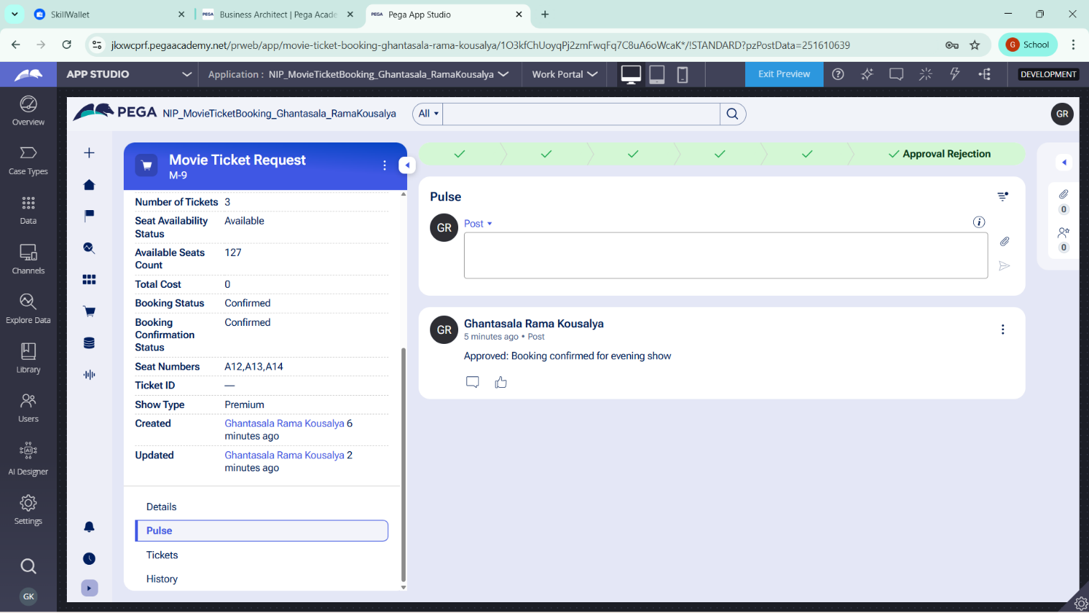

What I built for this (1–2 lines in your own words):
I created reusable Movie and Show data objects and linked them to the booking case. The data contains movie and show information such as movie name, genre, show date, show time and seat capacity.

US-006 — Review Booking Details
What is expected:
Confirmation screen shows Movie Name, Show Timing, Number of Tickets and Total Cost clearly.
Screenshot — paste your screenshot below this line:
[ Paste screenshot here - follow the screenshot rules above ]

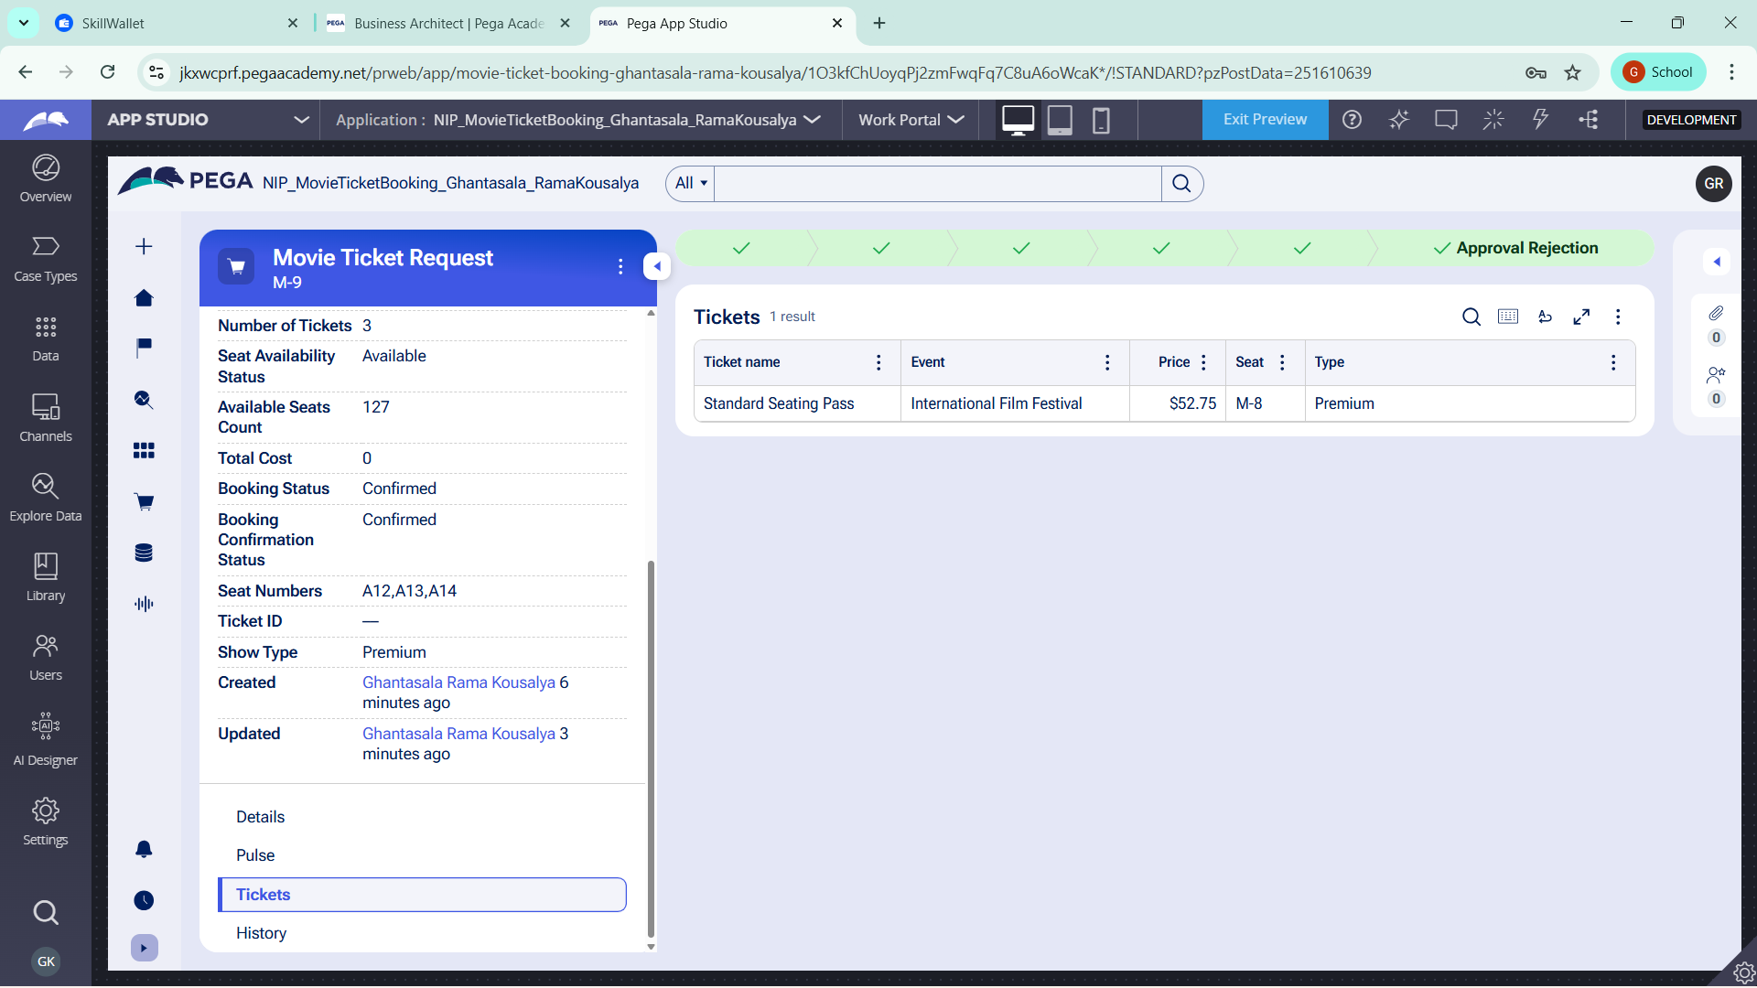

What I built for this (1–2 lines in your own words):
I created a confirmation/review screen that displays the movie name, show timing, number of tickets and total booking cost before the booking is completed.

US-007 — Process Ticket Booking
What is expected:
Booking Execution stage. Seat Numbers, Ticket ID and Booking Confirmation Status maintained.
Screenshot — paste your screenshot below this line:
[ Paste screenshot here - follow the screenshot rules above ]



What I built for this (1–2 lines in your own words):
I configured the Booking Execution stage to maintain the selected seat numbers, generate a Ticket ID and update the Booking Confirmation Status after successful processing.

US-008 — Notify Booking Confirmation
What is expected:
Correspondence rule triggered on case resolution. Email includes movie, show, seat and cost details.
Screenshot — paste your screenshot below this line:
[ Paste screenshot here - follow the screenshot rules above ]



What I built for this (1–2 lines in your own words):
I configured a correspondence notification that is triggered after the booking is resolved. The confirmation contains the movie, show, seat and booking cost details.

US-009 — Define Booking SLA
What is expected:
SLA configured on the case type. Goal: 1 day. Deadline: 2 days. Priority increases on breach.
Screenshot — paste your screenshot below this line:
[ Paste screenshot here - follow the screenshot rules above ]

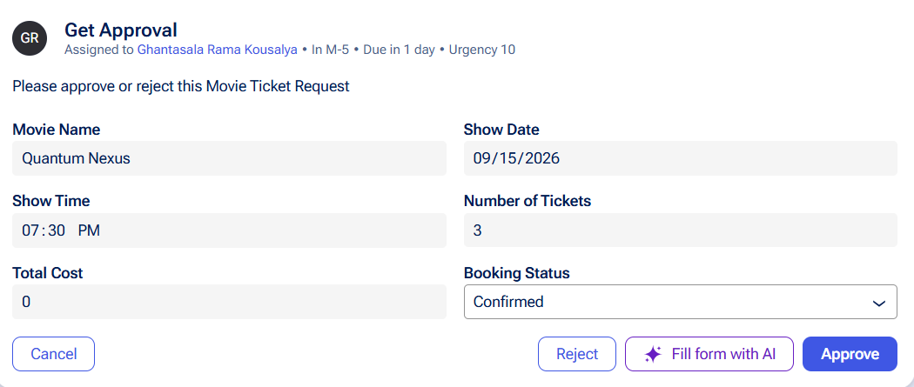

What I built for this (1–2 lines in your own words):
I configured an SLA for the Movie Ticket Request case with a goal of 1 day and a deadline of 2 days. The case priority increases when the SLA deadline is breached.

US-010 — Route by Show Type
What is expected:
Routing rule or Decision Table routes to PremiumShowQueue or StandardShowQueue based on Show Type property.
Screenshot — paste your screenshot below this line:
[ Paste screenshot here - follow the screenshot rules above ]



What I built for this (1–2 lines in your own words):
I configured routing based on the Show Type property. Premium shows are routed to PremiumShowQueue, while standard shows are routed to StandardShowQueue.

Section 3 — About Your Application
These answers are checked against your screenshots. Write exactly what is in your application.

Q1. List your stages in the order they appear in your case lifecycle.
Stage names in order, separated by commas.
Booking Request, Availability, Approval, Booking Execution, Inventory Management

Q2. Name the data object(s) you created and the properties inside them.
Data object name and its properties.
Attendee – Person who is watching movie
Event – The theater
Ticket – Movie Name, Genre, Show Date, Show Time, Seat Capacity

Q3. What is the exact name and type of the rule you used to calculate Total Cost?
Provide:
• Rule Name
• Rule Type
• Properties used in the calculation
• Formula used
Rule Name: Apply Promotions
Rule Type: Declare Expression
Properties: Ticket Price, Number of Tickets
Formula: Ticket Price × Number of Tickets

Section 4 — Your Understanding
Short, honest and specific answers score well.

Q4. What did Blueprint generate for you, and what did you add or change yourself afterwards?
Be specific about what was already there and what you built or modified on top.
[ Type here ]

Blueprint generated the initial Movie Ticket Request case structure, workflow stages, case fields, data objects and business rules. I then configured the booking forms, availability validation, Total Cost calculation, confirmation flow, booking processing, notification, SLA and show-type routing according to the project requirements.

Q5. Was there anything Blueprint created that you had to correct or configure further? Describe one example.
A real example from your own work.
[ Type here ]
Blueprint generated a ticket-type utility step that caused a runtime rule-resolution error when I tested the case. I investigated the flow and configured the process further so that the booking workflow uses the required movie-ticket steps instead of depending on the broken generated step.

Q6. Explain your case flow from creation to resolution, in order.
What happens first, who does what, when the case closes.
[ Type here ]

The customer first creates a Movie Ticket Request by entering the movie, show date, show time and number of tickets. The application checks show availability and calculates the booking cost. The customer then reviews and confirms or cancels the request. If confirmed, the booking is processed, seat numbers and Ticket ID are maintained, a confirmation notification is sent, and the case is resolved.

Q7. Pick two design choices you made in your application and explain why you made them.
For each design choice, provide:
• What you implemented
• Why you chose that approach
• What benefit it provides to the application
[ Type here ]
What I implemented: I configured booking requests to route according to the Show Type, such as Premium or Standard.
Why: Different types of shows can require different processing queues.
Benefit: It organizes booking work and demonstrates Pega's routing capability.

Q8. What was the hardest part, and how exactly did you fix it?
Specific and honest. A real challenge scores much better than a generic answer.
For me there were a issue with creating operator, I have seen recording and performed it. It was hardest part for me.

Q9. If the approval step was only needed when Total Cost is above a certain amount, what would you change in your application?
Explain what you would change and where. You do not need to build this.
[ Type here ]
I would add a condition before the Approval stage that checks the Total Cost. If Total Cost is greater than the defined threshold, the case would proceed to Customer Approval.

Q10. List three exact rule names from your application that you personally created or modified.
Include the rule name and rule type for each one (for example: CalculateTotalCost - Declare Expression).
[ Type here ]

Apply Promotions - Check if any promotions or discounts need to be applied.
Route Booking - Routes movie ticket booking requests to the appropriate work queue based on the show type.

Q11. List all personas used in your application.
List the persona names exactly as they appear in your application.
Attendee, Event Planner, Booking Manager, Ticket Manager, Customer, Sponsor, Vending Manager.

Q12. List all work queues used in your application and explain when each one is used.
For each work queue, provide its exact name and the condition or type of work routed to it.
[ Type here ]
PremiumShowQueue — Used when the Show Type is Premium.
StandardShowQueue — Used when the Show Type is Standard.

Before You Submit — Check These
Read through once before uploading.
1. Section 1 filled in. Application named as NIP-[Project]-[YourName]. Names match the actual application.
2. New Operator created in Pega with my full name. I logged in as that operator for all screenshots.
3. Only my chosen project section remains — the other project section is deleted.
4. All 10 user story screenshots are pasted and follow the operator, running-case, application, and rule-name evidence requirements.
5. Every question in Sections 3 and 4, including Q10, Q11, and Q12, is answered in my own words.
6. This file is named using the required format: ProjectName_FirstName_LastName.docx (for example, VehicleService_Ravi_Kumar.docx or MovieTicket_Ravi_Kumar.docx) and uploaded as required.

